Home First Floor
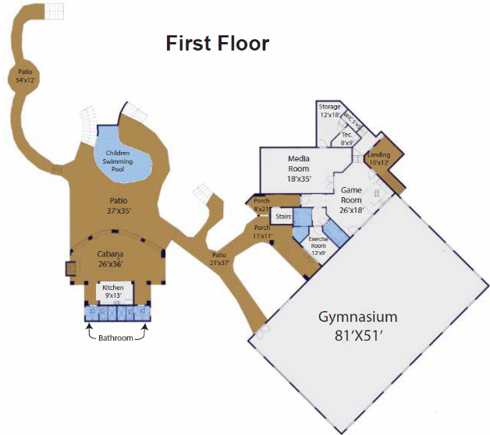
Gymnasium
- 16 6 ft. Round Tables
- 6 rectangular tables (6 ft)
- 158 chairs
- I basketball Shoot away (The Gun 10k)
Exercise Room
- I Peloton bicycle with shoes (2 pairs)
- Rack of hand weights
- 1 Peloton Black mat under bicycles
- 1 treadmill
- 1 black exercise ball
- 1 weightlifting bench
- 1 Portor on wheels
- Sauna Room – 2 towels
Bathroom
- 1 soap dish
- 2 plants
- 1 plant on back 0f toilet
- 1 towel hanging on rack1 picture above tole
Game Room
- 1 air hock game table
- 1 green plant
- 1 80" TV
- 6 bar stools without backs
- 3 tall decorative items
- 2 bar stools with backs
- 1 picture on wall
- Otis Spunkmeyer cookie maker
Media Room
- 12 reclining seats
- 1 Popcorn machine
- 12 Redlin machine
- 1 5 ft. old man stand statue
- 1 decorating movie wheel stand
- 1 decorative action board
- 2- pictures on walls
- Rest ON

Storage, Tec, & WIC
- 1 Gun Safe (large black) 3ft wide x 5ft tall
- I massage table ( Powered) /pillo, 1 hot pad
- 1 multi games unit ( Pac Man etc)
- 1 gaming table 4’x30” Mix box 30” with chair
- 2 Monitors
- 1 ping pong table with 3 paddles
- 2 American flags
- 1 Samsung monitor 30”
- 1 metal shelf 36” x 14” x 54”
- 1 HP Envy 120 printer scanner
Pool Kitchen
- Outside porch 1 10 ft table with 6 chairs
- I refrigerator ice box
- 1 large grill
- 1 Bathroom I has 2 pictures and 1 artificial plant
- 1 soap dish
- 2nd Bathroom has 2 pictures and 1 artificial plant
- 1 soap dish
- 1 fire pit with 3 cushioned chains
Pool Equipment House
- All necessary equipment to operate pool
- All necessary supplies for pool maintenance

Home Second Floor
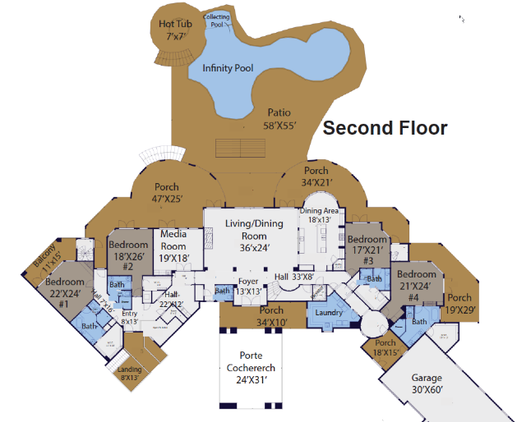
Rear outside patio
- 1 sofa and 4 swivel Chairs-l Sofa with cushions
- 1 fire pit coffee table
- 2 foot rests
- 1small coffee table
- Front porch 2 wrought iron chairs with cushions
Entry, Living Room, & Network
- Wall table
- Picture on Wall,3 candles on a stand
- Wooden round links on table tray
- Oval brass tray with decorative bulls
- 2 horse heads together on table
- wooden box on bottom shelves of table
- 5 by 7 in area rug
- 2 hanging pictures on Wall
- 1 Small sitting stool
- 2 wooden octangle shaped stands
- 1 glass vase with tall weed
- Giraffe Picture on opposite Wall
- 2 Living Room Leather Sofa's
- 3 club swivel chairs
- 1 large leather coffee table
- 3 round end tables
- 5 decorative pillows - white oval vase with
- 1 10’ by 14’ rug
- 4 brass pots on metal stands with green plants
- Brass horse on mantal
- Wall cabinet with 4 doors
- 80” tv
- 2 large mirrors
- Dining Room
- 1 large table with 6 chairs
- 1 wall table with a 5-candle tray
- vase with brass ball sitting on top
- 1 large artificial tree by stairs
Laundry Room
- 2 washing machines
- 2 Dryers
- Cabinet full of towels and linens
- 1 green plant in a pot
- 1 decorated white metal flower in window
- 3 wash Dry Fold plaques
- Love plaque over sink
- 2 TVs on floor
- Storage closet
- miscellaneous cleaning products
- 2 vacuum cleaners
- Half bathroom
- Alcove wall table
- 3 wall hangings
- 1 Picture and green plant in pot
- Small Shelf table
- Fancy cross on bottom of table
- green plant on top
- seif 2 glass vases
- small Rug
Network Equipment Room
- Network Server with rack wiring and equipment
Kitchen
- Round wooden table with 6 Chairs
- 2 oil Bottles on tray
- I glass top butter dish or cooktop
- Coffer maker, 4cup holder
- Sugar a coffee container
- 33" small tv. at bar wall
- decorative plant on tray with 2 soap dispensers
- 3 wall hangings
- 1 large ceramic pot with greenery
- 1 tall glass vase with fake fruit
- Salt and pepper on tray
Bedroom 1 and Bath
- 1 King size bed with box spring and mattress
- 2 blankets I coverlet and 6 pillows and set of sheets
- 2 king chairs with decorator pillows ea.
- 3 side tables, 1 lamp and 4 pictures
- 2 side table lamps
- 65” TV over Fireplace
- 2 sconces
- 1 small green plant
- Bathroom
- 3 hanging Pictures
- Tub tray toilet Room
- Shelf over toilet
- Tub tray with 4 decorative items
- 2 soap dispensers
- 2 cotton ball Jurs
- 1 artificial green plant
- 1 large towel
- 1 hand towel
- 3 wash cloths
- 4 pictures in hallway next to media room
Bedroom 2 and Bath
- 1 Queen bed with box spring and mattress and coverlet
- 7 decorative pillows
- 1 throw blanket
- 2 lamps
- 1 Night stand
- 5 plaques on wall
- 1 picture
- 1 mirror
- 1 wall table
- 1 dresser table
- 1 large pot with black feathers
- 1 Chair
- 1 foot stool
- 1 throw blanket
- 1 black stand with black box with artificial plant
- 1 black stand with plant
- 1 black table with 2 wicker pots on bottom shelf
- 1 artificial green plant
- 1 45” TV
- Bathroom
- 5 large towels and 5 hand towels
- 6 hanging depurative items on walls
- 2 candles
- 1 cotton bull
- 1 soap jar
- 3 wooden black animals and 3 white wooden monkeys
- Wall outside media room
- Artificial greenery in black containers on shelf
- 1 minnow and 3 white pictures
- Media Room:
- 90" TV with table
- floor lamp
- Tan leather sectional Sofa
- 2 small decorative boxes
- 1 Coffee table with bowl
- 6 decorative pillows
- 1 Large plant in container
- 2 large pictures on wall
- Decorative item/flower arrangement
- 1 large cow picture at base of stairs next to media room
Bedroom 3 and Bath
- King Size Bed with box spring and mattress and one set of sheets
- coverlet - 3 decorator pillows
- 1 yellow throw Blanket
- 2 nightstands
- 1 round metal table with 1 lamp
- 1 Wall table under TV
- 10 decorative items on walls
- 2 ceramic fish
- 1 Shower pot
- 1 glass tray, green pot
- 2 tall blue containers
- 2 decorator plates under table
- 2 catus plants in wicker baskets
- Bathroom
- 3 Towels
- 2 soap containers
- 2 small greenery plants
- 2 cotton balls Jars
- Tray with 2 glasses
- 2 small greenery plants
- 2 cotton ball jars
- 2 hanging plants on wall
- hanging plants or walls
- Outside in hall are 2 king chairs in the inside foyer
Bedroom 4 and Bath
- 1 king bed and 1 box spring and mattress
- 1 coverlet with 4 decorative pillows
- 2 nightstands
- 2 lamps
- 4 hanging pictures
- 1 leather sofa and 7 decorative pillows
- 1 wooden coffee table
- 1 green plant
- 4 small plants
- Bathroom
- 4 shelf items
- 4 large towels 2 hand towels
- 4 pictures on the Walls, soap dispensers
- 4 green plants
- 1 cotton ball jar
- 2 soap dispensers

Home Third Floor
Bedroom 5 and Bath
- 1 king bed 1 box spring and mattress and 1 set of sheets
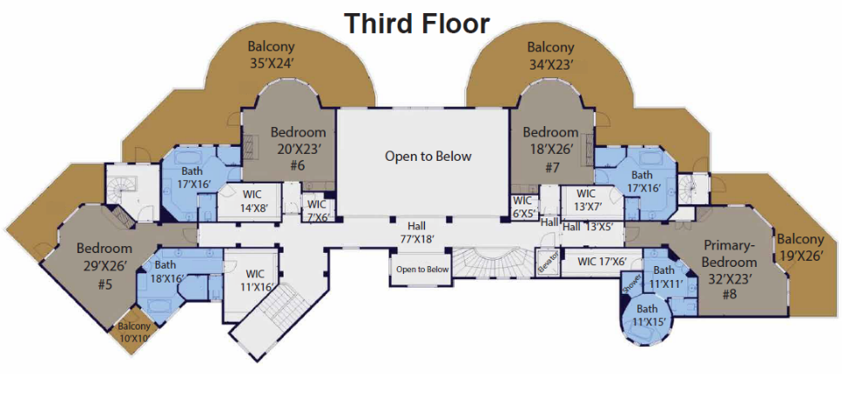
- 1 Coverlet
- 9 Bed pillows
- 2 nightstands
- 2 lamps
- 2 Chains
- 1 round glass table, chair
- 1 large tv over fireplace
- 1 White wall table
- 7 Wall decorative items
- 1 seashell bowl
- 1 green plant in white bowl
- 2 wooden pictures on wall
- Bathroom
- 3 large towels
- 3 wash clothes
- 2 hand towels
- 1 Round metal Shelf on wall
- 7 decorative items on Walls
- 2 Soap dispersers
- 1 candle in large round container
- 2 large candles in holders at tub
- 1 rock in plate at tub
- 6 decorative items on counter
Bedroom 6 and Bath
- 1 King Bed and1box spring 1 mattress
- 1 coverlet - 4 pillows
- 2 nightstands
- 1 table lamps
- 1 Large tv over fireplace
- 2 orange chairs
- 1 glass table
- 3 pictures on walls
- 1 coffee pot at coffee counter
- 1 sugar container (metal)
- 1 round mirrored tray with 2 cups
- 1 small elephant on counter
- 1 orange Flowerpot
- 1 small orange vase
- 3 small decorative mirrors on wall
- Bathroom
- 2 wall hangings
- 4 large orange towels
- 4 wash clothes
- 2 hand towels
- 2 wall hangings
- 1 large decorator box with lid
- 1 large candle in glass pedestal jar、
- 4 plastic cotton ball containers
- 2 soap dispensers
- 1 gold metal box holding washcloths’
- 1 green Plant in tall wooden box
Bedroom 7 and Bath
- 1 King Size bed and 1 boxspring and mattress
- 1 King coverlet,5 pillows on bed
- 2 nightstands
- 2 table lamps
- 5 plant arrangements
- 1 floor lamp
- 2 pictures on wall
- 2-bedroom chairs
- 1 glass round metal chair table
- 1 large tv over fireplace
- 5 shelf items
- 1 small white area rug
- Bathroom
- 2 large towels
- 1 Tall glass pestle container
- 1 hand towel
- 3 flowers in 3 vases
- 3 pictures on wall
- 4 plastic cotton ball jars
- 2 soap and hand lotion trays
- 2 White bowls
Bedroom 8 and Bath
- Queen size bed and 1 box spring and mattress
- 1 coverlet and 5 pillows
- 1 throw blanket
- 1 nightstand
- 3 lamps
- 1 artificial tree in a pot
- 1 wall table
- 2 greenery plants in pots
- 6 decoctive items
- 1 large tv over fireplace
- 1 sofa with 5 pillows
- 1 coffee table
- 1 dresser with mirror
- 5 pictures on Walls
- Bathroom
- 3 pictures on wall
- 4 plastic containers ball Jars
- 3 tall Candles Holders with 3 candles
- 1 tv on floor in room closet
- 3 speakers in closet
- 4 artificial plants in the window

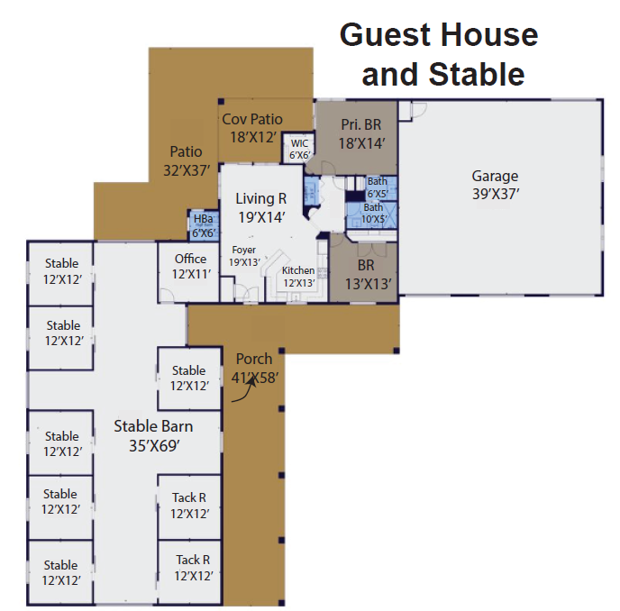
Guest House
- Living Room
- 1 sofa lounge with foot stool
- 4 round bar stools
- Portable picture Ladder rack
- Kitchen
- 4 Round bar stools
- 1 refrigerator/freezer
- Bedroom 1
1 set white bunk beds with storage
- Hall: Washer and Dryer
- Bedroom 2
- Queen Size Bed box mattress and bed mattress
- coverlet
- 1 small chest of drawers
- 1 large credenza with drawers
- Patio has 1 table and 6 chairs
Guest house garage
- 1 dining table and eight chairs
- 1 gray sofa
- 2 credenzas
- 1 top of a credenza
- 1 bed set frame
- 1 rollaway bed
- 3 wrought iron porch chairs
- 1 wooden flag picture
- 1 land of the free picture
- All supplies on shelves

